Databases Assignment 1  
Jesse Carter  
B00694792

Logical Data Model:

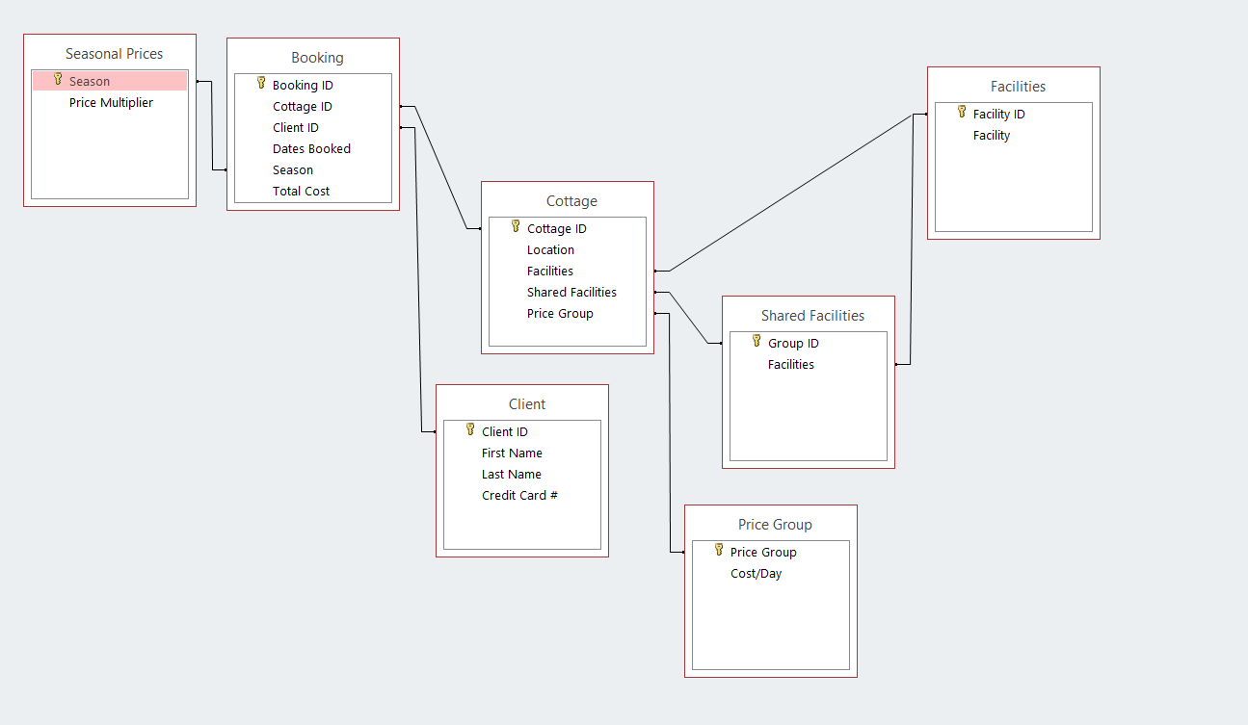

Physical Data Model:

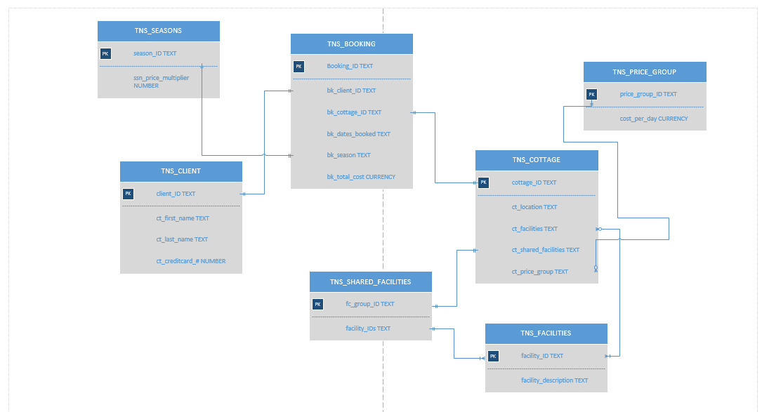

**Please zoom in on the physical model to see the relationships!** They are marked, but I could not find a way to format the visio diagram so it would be legible without zoom and fit onto 1 page. Sorry for the inconvenience!

Booking Table:



Client Table:

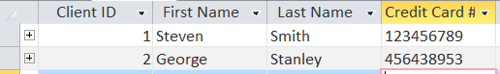

Cottage Table:

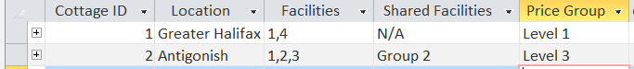

Facility Table:

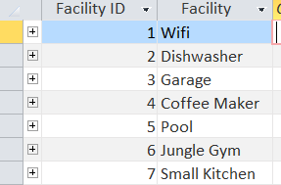

Shared Facility Table:

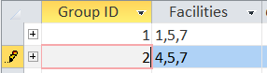

Price Group Table:

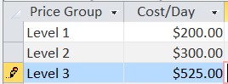

Season table:

